**Quantitative Research Analysis**

**Written Report**

**By: Selam, Indeya,**

**Mohammad,**

**Colin, & Kristina**

**Date: April 25, 2022**

**Salem and Roanoke College Dining**

**Introduction**

Our research focused on dining patterns of Roanoke college students on campus (i.e., Commons, Rooneys, and Freshens) as well as in Salem, VA. We looked at how often students went to entertainment events on campus. We then compared it to how often students went to events off-campus around Salem. Overall, we viewed the satisfaction of all elements and specifications listed. We found many conclusions and recommendations based on the results of the analysis of the survey data, discussed below in our report.

**Research objectives**

Our research objective was to see how satisfied RC students were with the dining options on campus and around salem. We wanted to see if they were happier with one option over the other, as well as their overall satisfaction with the dining options, locations, and food choices. The objectives we looked at were: determining current demand and satisfaction for dining options both around Salem and RC, determining the ways RC can improve the current options, and determining if there should be new options for dining and if so, what would students want to see around these places.

**Results**

**Frequency:**

Majority of students do eat on campus (78.5%). The 14 meal plan is the most popular (46.2%), followed by the 9 meal plan (16.9%), and about one-third of the population does not have a meal plan (29.2%). Majority of the population (89.2%) do not have any dietary needs/restrictions. Interestingly, 0% of the population was reported to have any sugar-free, gluten-free, kosher, vegetarian, or vegan needs/ restrictions. The population generally eats 5-9 (30.8%) meals per week in Commons, closely followed by 1-4 meals per week at 29.2%. 23.1% of the population reported that they eat 0 meals at Commons per week. Low percentage of 16.9% of the population eats 10 or more meals at Commons. Just about half of the population eats at Freshens (49.2%) for 1-4 meals, followed by 0 meals at (43.1%) who reported eating at Freshens 0 times per week. More than half of the population eat 0 meals per week from Rooney’s Brews (60%). Regarding eating on campus, the majority of the student population eats lunch (78.5%), followed by 67.7% who eat dinner. 20% of the population eats breakfast, 18.5% eats brunch, and 15.4% of the population do not eat on campus for any meal. 61.5% of the population eats off campus 1-4 times per week, followed by 23.1% that eats off campus 5-9 times per week. Just over 5% (6.2%) do not eat off campus at all (0 times per week), and 9.2% eat off campus 10 or more times per week.

Regarding eating off campus, almost the entire population (93.8%) eats dinner off campus. When asked where they eat off campus, almost the entire population eats at Mac and Bob’s and Chick-Fil-A. (81.5%) both tying at that percentage. 52.% of the population eats at Macado’s. About 70% (69.2%) of the population will spend $10-$15 per meal off campus, followed by 16.9% who would be willing to spend $15-$20 per meal off campus. While only 3.1% would be willing to spend $20 or more per meal off campus. As far as satisfaction with RC dining services, almost half (41.5%) were somewhat satisfied with the dining options, while 4.6% were extremely satisfied. 36.9% of the population is somewhat satisfied with Commons, 55.4% is somewhat satisfied with Freshens, and 38.5% is somewhat satisfied with Rooney’s Brews. As far as dining options around Salem, about half (50.8%) of the population is somewhat satisfied, leaving 30.8% extremely satisfied, and 1.5% extremely dissatisfied.

29.2%, which is about 1/3rd of the population, said that they strongly disagreed with the statement that there is enough variety of food options on campus. The demand for more late night food options on RC’s campus was at 75.4%. As far as to-go options, 36.9% of the population reported that they neither agree nor disagree with preferring their food to go. 33.8% for both somewhat agree and strongly agree that new dining options should be grab and go. Majority (46.2%) strongly agree that Commons/Cavern is in convenient locations. 29.9%, almost 1/3rd of the population, strongly agrees that the price of dining options on campus is acceptable. 38.5% somewhat agree that dining services offer healthy food options. Again, in the middle, at ⅓ (30.8%) of the population doesn’t agree or disagrees that dining services offer high quality food. 41.5% of the population somewhat agrees that seating capacity of Commons is appropriate to fit the needs of the student population.

Over half (59.9%) reported that new dining options should be available on campus. 40% strongly agree that they would like to see fast food stands nearby or on campus. 72.3% reported that they would strongly agree they would like to see more mobile ordering options for food on campus. 36.9% of the population neither agree nor disagree that there should be more dining options in Salem. The population reported 53.8% to be seniors, 20% to be juniors, 20% to sophomores, 6.2% to be freshmen. 58.5% of the population is female and 41.5% is male. 66.2% of the population lives on campus, 30.8% lives off campus, and 3.1% are commuters. Majority of the population (63.1%) are 21 or older, 35.4% are under 21, and 1.5% preferred not to say. The full analysis results can be found in *Tables 1.1* to *Tables 1.46*.

**Crosstabs:**

For crosstab analysis, we tried to investigate the influence of dietary needs on whether students dine on campus. Our two variables of interest were the number of meals students ate at Commons and whether or not they lived on-campus/off-campus. Conducting the analysis, we found that the total number of students that ate on campus were 43, off-campus were 20, and commuters were 2 (*Table 2.1*). We also found the relationship between the two variables significant (.001, *Table 2.2*), meaning that there is a relationship between dietary needs and students’ accommodation. This made it clear that if students live on campus then they are most likely to eat at Commons.

**T-test:**

For the T-test analysis we assigned gender as the dependent variable and variety of food options on-campus as the independent variable to see if there is any relationship between the two. Our findings concluded that there is no significant relationship between gender and variety of food options, thus, implies that both genders' have a similar opinion when it comes to the variety of food options offered on-campus (*Tables 3.1 & 3.12* ).

**ANOVA:**

For the ANOVA, we used education level as the dependent variable and overall satisfaction with RC’s dining services as the independent variable. We wanted to investigate if there was any relationship between students’ education level and their overall satisfaction with RC’s dining services. The results of the analysis revealed that there was no significant relationship between RC students’ class level and their overall satisfaction with RC’s dining services (.658, *Table 3.21*).

**Regression:**

For our first multiple regression, we wanted to see if gender plays a role in determining how many meals students eat at the different on-campus dining locations. We used gender as the dependent variable and three independent variables (i.e., number of meals from Commons, number of meals from Freshens & number of meals from Rooneys). The regression model summary (*Table 4.1*) revealed the adjusted R squared value to be .201 which informed us of the effectiveness of our model. It implied that gender only explains 20.1% of the differences observed in the number of meals students get from the different dining locations on campus. The ANOVA analysis (*Table 4.12*) indicates that the difference observed was statistically significant as the p-values (i.e., 0.003 & .001) were less than the significance level. The coefficients analysis indicating the regression equation is found in *Table 4.13*.

We found the results of this analysis a little surprising since we did not expect gender differences to be significant in determining how many meals students eat at Commons, Freshens and/or Rooneys. The Model Summary indicated that only about 20% of this significant difference is explained by gender thus suggesting that the majority (80%) of the difference is as a result of other factors other than gender. This explained that even though the difference was significant, it only accounted for a small portion of the difference. We had several hypotheses and explanations to account for the 20% difference, one of the most mentioned was the strong preference for specific dining places on campus. We were able to verify this hypothesis by looking at the descriptive statistics summary (*Table 4.14*) which indicated that most RC students dine at Commons (i.e., with an average of 2.42 ) compared to the other two dining options.

Our second multiple regression focused on overall satisfaction with RC’s dining services. We wanted to investigate the satisfaction level of RC students with the dietary accommodation of food options, with the prices of the different dining options, and with the availability of healthy food options at the dining places on-campus. The regression model summary (*Table 4.21*) revealed the adjusted R squared value of .277 which informed us of how effective our model is. The value suggests that 27.7% students' overall satisfaction with RC’s dining services is explained by dietary accommodations, food prices and the availability of healthy food options. This means that 72.3% of their overall satisfaction is explained by some other factor other than the three factors stated. The ANOVA table (*Table 4.22*) indicates that the difference observed was significant as the p-value was statistically significant (.001). The coefficients analysis table indicating the regression equation for the model can be found in *Table 4.23*.

The results of this investigation were not very surprising considering the number of factors that can affect overall satisfaction regarding dining services. Nevertheless, from the descriptive statistics table (Table 4.24) we were able to tell that the majority of the students had similar satisfaction ratings looking at the standard deviations. We were also able to discover that students’ were more satisfied with the dietary accommodations (i.e., with an average of 3.69) than with the prices or the availability of healthy food options. As a group and as Roanoke college students, we were able to recognize the reasoning behind the results we obtained. Some of the explanations we thought of included Commons’ dietary accommodation for vegans and vegetarians, and their gluten free options. Moreover, having the option of making orders with specific instructions at Freshens and Rooneys also gives students the accommodations they need. Therefore, we were very convinced with the outcomes of this investigation.

**Correlation:**

As for the Correlation analysis, we investigated the relationship between the number of times students eat off-campus and overall satisfaction with dining options on Roanoke College. We were trying to see if there is a relationship between the level of satisfaction with food on-campus and the number of times students ate off campus. From the results, we were able to find out that there was no significant relationship between satisfaction level on campus and the number of times students ate off campus (.155, *Table 5.2*).

**Limitations**

Some limitations we faced include convenience sampling, and the inability to generalize about Salem’s dining and entertainment options as it entails only RC students. This means that the external validity of our study is low. Another limitation we faced is a small sample size. This also makes it difficult to generalize about the opinions of the entire RC community. Having a bigger sample size would have at least made us confident about the generalizability of our results to RC. Other challenges we faced excluding the research process is difficulty in trying to find the most suitable time to meet for all group members.

**Conclusions**

According to our overall findings and the data analysis, we can conclude that the majority of students do eat on campus, and that the most popular meal plan reported to be the 14 meal plan. Almost 100% of the population does not have dietary needs/restrictions. Dinner seems to be the most popular meal to dine off-campus for, as Mac and Bob’s and Chick-Fil-A tied with almost 90% of the population eating at one of the two restaurants when they do eat off campus. The demand from the population for new dining options on campus, more mobile ordering options, and late night dining options is pretty great amongst the students.

In our other analyses, we found there is a slight relationship between the number of meals students get from Rooneys, Commons, and/or Freshens and their gender. Although, this significance only accounted for 20% of the difference. Additionally, we discovered that students' overall satisfaction with Roanoke College’s dining services is related to the dietary accommodations, food prices and the availability of healthy food options at the dining places. However, we did not find any relationship between gender and variety of food options on-campus. We also did not find any significant relationship between the number of times students eat off-campus per week and their overall satisfaction with RC’s dining services.

Additionally, we discovered that students who live on campus are more likely to eat at Commons and that dietary needs and students’ status of living (on-campus/off-campus) correlate with each other. However, we did not find any relationship between students’ class level and their overall satisfaction with RC’s dining services. We also found out that overall satisfaction with RC’s dining services did not influence the number of times students ate off campus.

**Recommendations**

Roanoke College can use these findings to conduct an in depth research and additional investigations to bring strong evidence up front to the decision makers. They could conduct a student forum to get feedback of students' wants/needs to accommodate them. They could also utilize the data findings to ensure student satisfaction which could help with Roanoke College’s retention. RC could offer the variety of desired options suggested by students to ensure satisfaction; options like advanced digital ordering, fast food options such as a Chick-Fil-A etc. Moreover, they can improve the quality of foods offered on campus. For instance, to improve the foods in Commons they could try and use a new distributor.

**Appendices**

1. **Frequencies:**

**Table 1.1: Frequency table for if the population eats on campus or not**

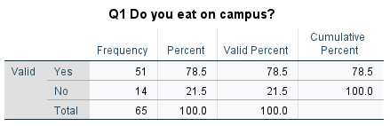

**Table 1.12: Frequency table for what meal plan the population has**

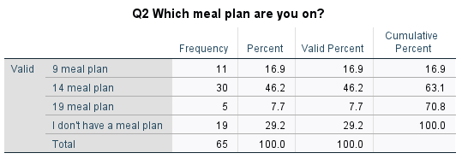

**Table 1.13: Frequency table for dietary needs**

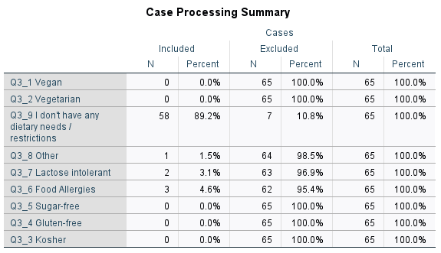

**Table 1.14: Frequency table for Frequency table for how many meals the population eats at Commons per week.**

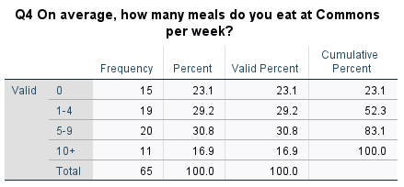

**Table 1.15: Frequency table for Frequency table for how many meals the population eats at Freshens per week.**

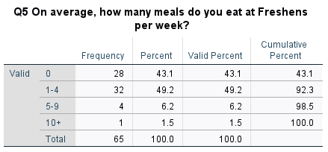

**Table 1.16: Frequency table for how many meals the population eats at Rooney’s Brews per week.**

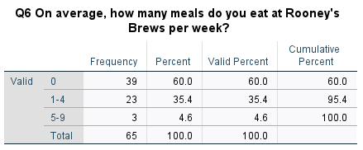

**Table 1.17: Frequency table for Frequency table for when the population eats on campus**

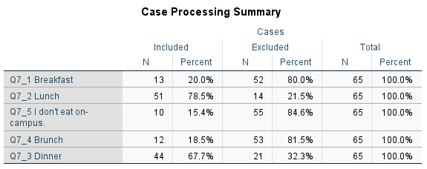

**Table 1.18: Frequency table for how many times the population eats on campus**

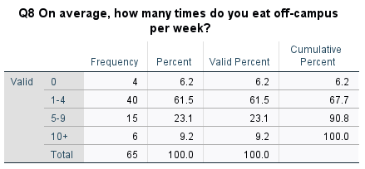

**Table 1.19: Frequency table for when the population eats off campus**

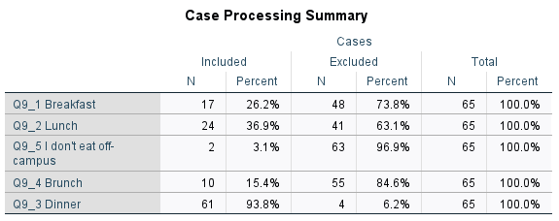

**Table 1.20: Frequency table to analyze where the population eats at when they eat off campus**

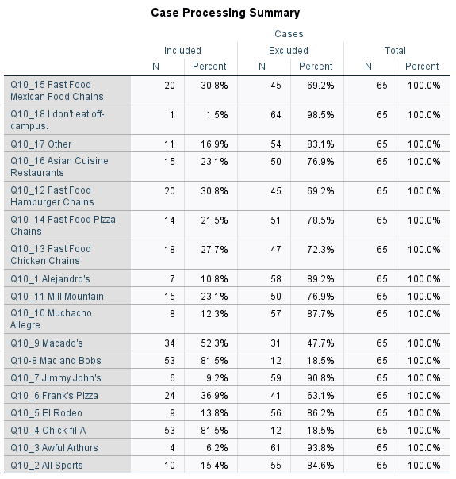

**Table 1.21: Frequency table for how willing the population is willing to spend per meal off campus**

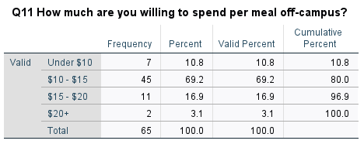

**Table 1.22: Frequency table for agreement/disagreement with satisfaction with dining services over all.**

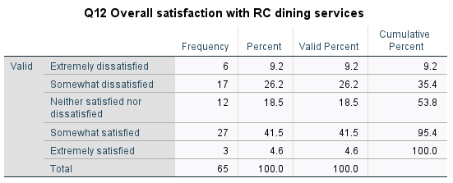

**Table 1.23: Frequency table for agreement/disagreement with satisfaction with Commons**

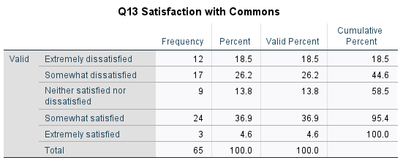

**Table 1.24: Frequency table for agreement/disagreement with satisfaction with Freshens**

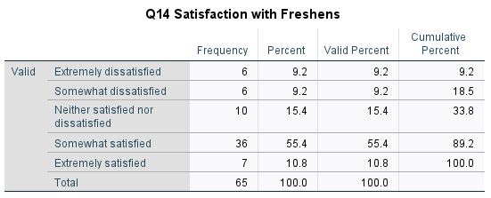

**Table 1.25: Frequency table for agreement/disagreement with satisfaction with Rooney’s Brews**

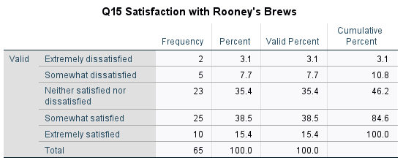

**Table 1.26: Frequency table for agreement/disagreement with satisfaction of dining options around salem.**

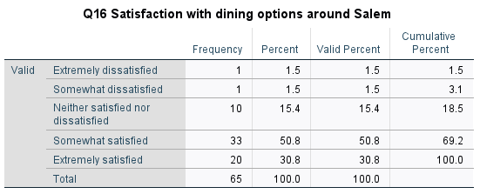

**Table 1.27: Frequency table for agreement/disagreement with food options accommodating dietary needs.**

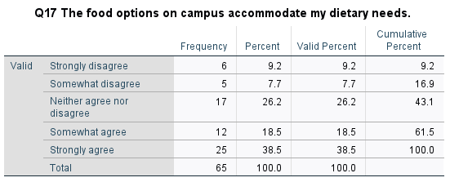

**Table 1.28: Frequency table for agreement/disagreement with if campus has enough variety of food options on campus**

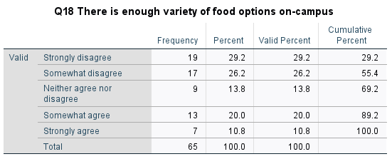

**Table 1.29: Frequency table for agreement/disagreement with late night food option needs**

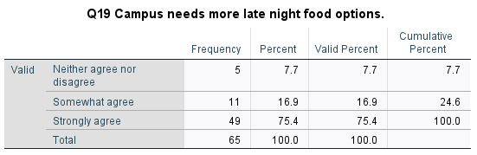

**Table 1.30: Frequency table for agreement/disagreement with preferences of food to go**

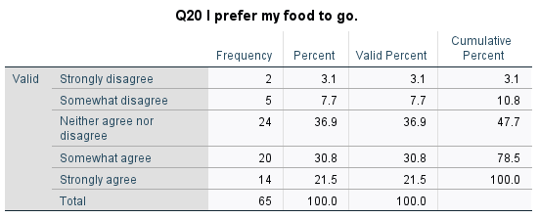

**Table 1.31: Frequency table for agreement/disagreement with the location of Commons and Cavern**

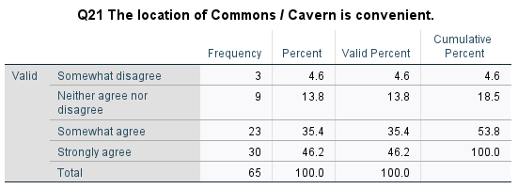

**Table 1.32: Frequency table for agreement/disagreement with satisfaction of hours for dining services**

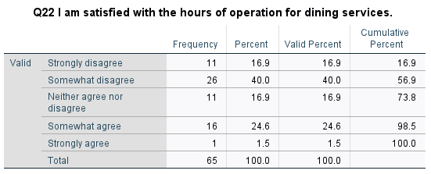

**Table 1.33: Frequency table for agreement/disagreement with the price of dining options**

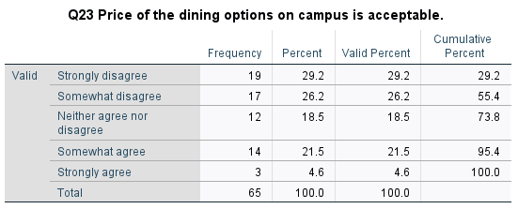

**Table 1.34: Frequency table for agreement/disagreement with there being a need for more dietary needs.**

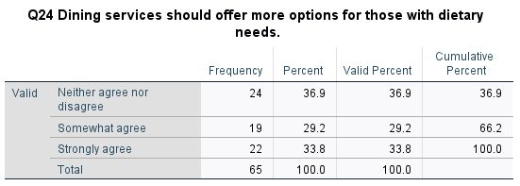

**Table 1.35: Frequency table for agreement/disagreement with healthy food options being available**

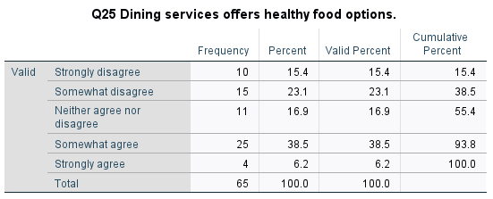

**Table 1.36: Frequency table for agreement/disagreement with high quality food**

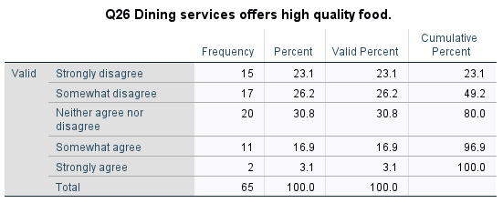

**Table 1.37: Frequency table for agreement/disagreement with Commons having appropriate fit for student population needs**

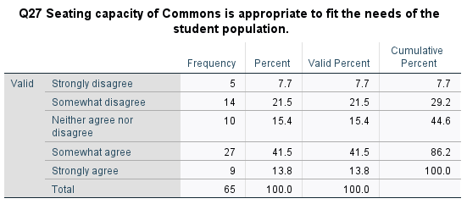

**Table 1.38: Frequency table for agreement/disagreement with adding more dining options**

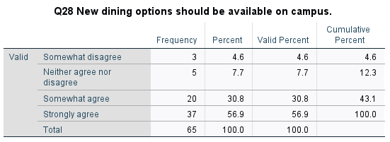

**Table 1.39: Frequency table for agreement/disagreement with new dining options that offer grab and go**

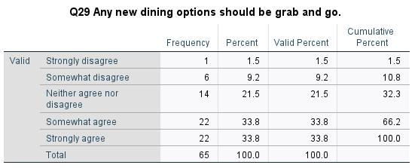

**Table 1.40: Frequency table for agreement/disagreement with adding more fast food stands on campus**

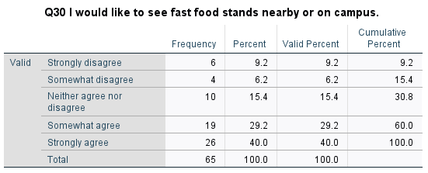

**Table 1.41: Frequency table for agreement/disagreement with adding more ordering options**

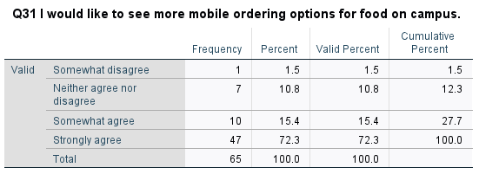

**Table 1.42: Frequency table for agreement/disagreement with adding more dining options in salem**

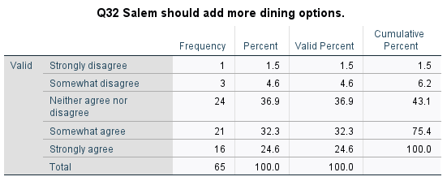

**Table 1.43: Frequency table for Class standing**

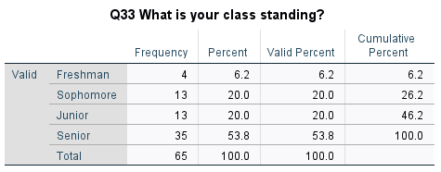

**Table 1.44: Frequency table for Gender**

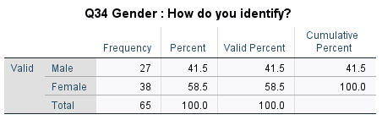

**Table 1.45: Frequency table for living on or off campus**

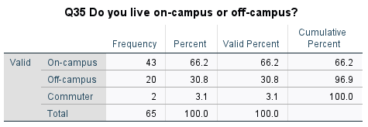

**Table 1.46: Frequency table for Age**

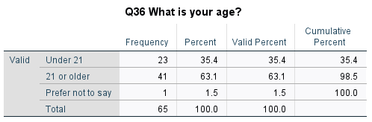

1. **Crosstabs:**

**Table 2.1: Crosstab table for the number of meals students ate at Commons and living status in college**

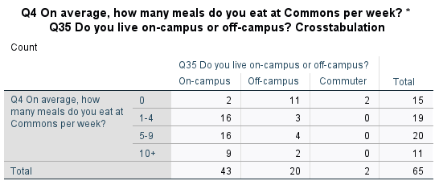

**Table 2.2: Chi-Square test for the number of meals students ate at Commons and living status in college**

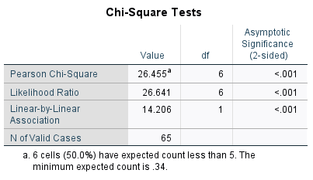

1. **Group Comparisons:**

**I. T-tests**

**Table 3.1: Group Statistics for Gender & Variety of Food Options On-campus**

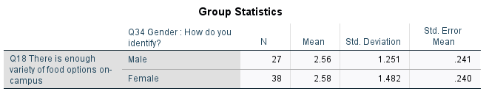

**Table 3.12: Independents Samples t-test for Gender & Variety of Food Options On-campus**

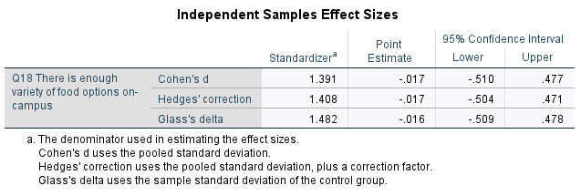

**II. ANOVA**

**Table 3.21: ANOVA table for Students’ Class Standing & Overall Satisfaction With Dining Services at RC**

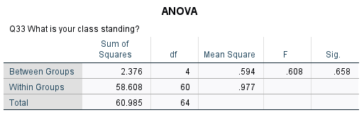

**Table 3.22: Post Hoc test for Students’ Class Standing & Overall Satisfaction With Dining Services at RC**

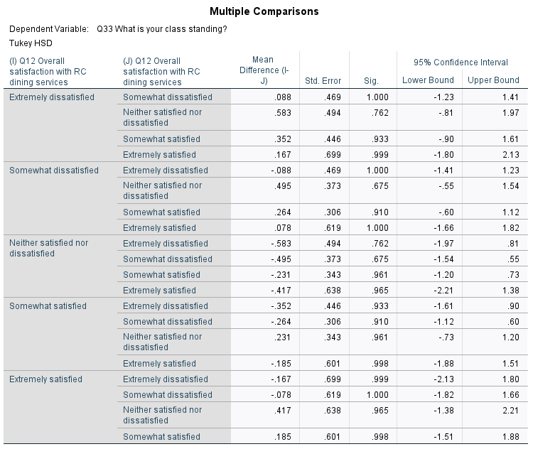

1. **Multiple Regression:**

**Table 4.1: Model Summary for Gender and Meals from Commons, Freshens & Rooneys.** 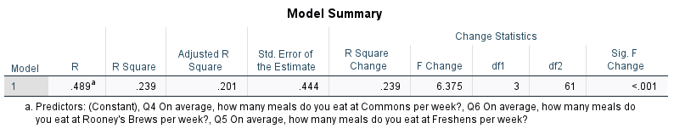

**Table 4.12: ANOVA Analysis for Gender and Meals from Commons, Freshens & Rooneys.**

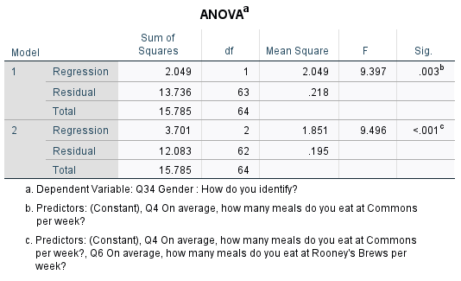

**Table 4.13: Coefficients table for Gender and Meals from Commons, Freshens & Rooneys.**

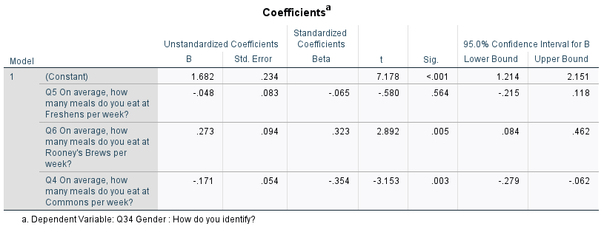

**Table 4.14: Descriptive Statistics for Gender and Meals from Commons, Freshens & Rooneys.**

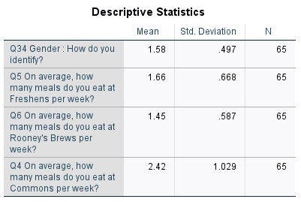

**Table 4.21: Model Summary for Overall Satisfaction, Dietary Accommodations, Food Prices & Availability of Healthy Food Options on RC’s Campus**

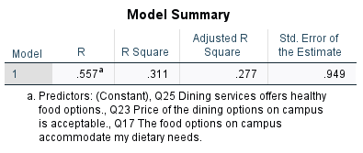

**Table 4.22: ANOVA Analysis for Overall Satisfaction, Dietary Accommodations, Food Prices & Availability of Healthy Food Options on RC’s Campus**

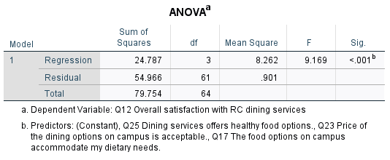

**Table 4.23: Coefficients table for Overall Satisfaction, Dietary Accommodations, Food Prices & Availability of Healthy Food Options on RC’s Campus**

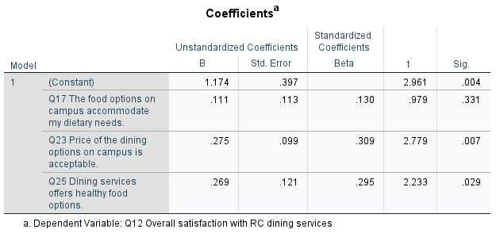

**Table 4.24: Descriptive Statistics for Overall Satisfaction, Dietary Accommodations, Food Prices & Availability of Healthy Food Options on RC’s Campus**

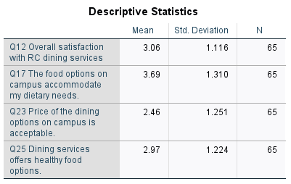

1. **Correlation:**

**Table 5.1: Descriptive Statistics for dining off-campus and overall satisfaction with food on-campus.**

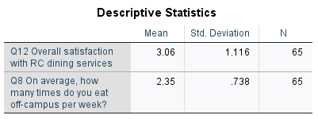

**Table 5.2: Correlation analysis for dining off-campus and overall satisfaction with food on-campus.**

